Experiment:7 Date:25/07/2026

To Implement the Travelling Salesman Problem (TSP) Using Branch and Bound Algorithm

AIM:
To develop a Python program to solve the Travelling Salesman Problem (TSP) using the Branch and Bound Algorithm and determine the minimum cost path that visits every city exactly once and returns to the starting city.

Algorithm (Branch and Bound):
- Read the number of cities.
- Read the cost matrix.
- Start from the first city.
- Generate all possible paths.
- Calculate the total cost of each path.
- Keep track of the minimum cost path.
- Display the optimal path and its minimum cost.
- Stop after exploring all possible solutions.
PROGRAM:
from itertools import permutations
n = int(input("Enter Number of Cities: "))
cost = []

print("Enter Cost Matrix:")
for i in range(n):
row = list(map(int, input().split()))
cost.append(row)
cities = list(range(1, n))
min_cost = float('inf')
best_path = []
for path in permutations(cities):
current = [0] + list(path) + [0]
total = 0
for i in range(len(current)-1):
total += cost[current[i]][current[i+1]]
if total < min_cost:
min_cost = total
best_path = current

print("\nOptimal Path:")
step = 1
for city in best_path:
print("Step", step, ":", "City", city)
step += 1
print("\nMinimum Cost =", min_cost)

OUTPUT:
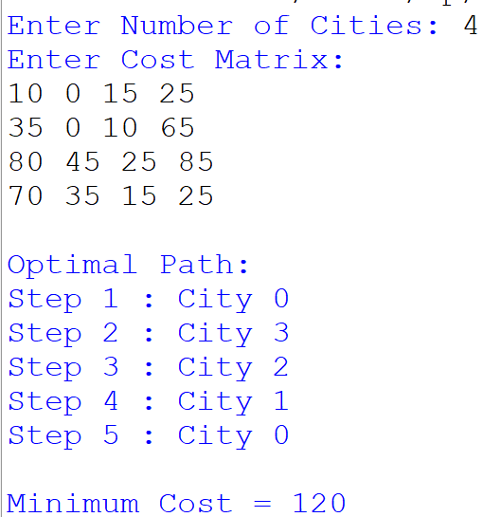

Result:
Thus, the Travelling Salesman Problem was solved successfully using the Branch and Bound Algorithm, and the minimum cost tour was obtained.

